

Academic Recruitment Guidelines

For Academic Searches

For Questions: [acadadmn@iu.edu](mailto:acadadmn@iu.edu)

Contents

Introduction 3

Getting Started 3

Checklist for Academic Searches in PeopleAdmin 4

Create a Search Waiver Request 5

Create from Position Type 5

Creating a New Posting 6

Create from Position Type 6

Place the Ad 11

Candidates Apply 12

Reviewing Applicants 12

To view an applicant’s documents one at a time 12

To view an applicant’s materials as a single file 13

To view a collection of applicant documents 13

To view the applicant’s materials as separate documents 13

Move Applicants to a Workflow State 13

Review List 13

Single Applicant 13

Multiple Applicants 14

Rejection 14

Single Applicant 14

Multiple Applicants 14

Request Interview 15

Single Applicant 15

Multiple Applicants 15

Schedule Interview 15

Declined Interview 15

Single Applicant 15

Multiple Applicants 15

Interviewed 16

Lead Candidate 16

Not Selected 16

Offer Packet - OCRC requires an academic position announcement must be advertised in PeopleAdmin for 30 days before an offer can be made 16

Approval of Terms/Required Documentation 16

Offer Letter Template 16

CV 16

Other Required Documents 16

Fire Form approval 17

Assemble Offer Packet Document 17

Hiring Proposal - OCRC requires an academic position announcement to be advertised in PeopleAdmin for 30 days before an offer can be made 17

Create Hiring Proposal 17

Edit a Returned Hiring Proposal 18

Finalize Hiring Proposal 19

Offer Accepted 19

Offer Declined 19

Final Transitions 20

Final Transition on Applicant 20

Final Transition on Posting 20

Troubleshooting 20

Viewing Draft Applications for a Position 20

File Too Large for Proposal 22

# Introduction

All AC1 positions, except postdocs and visiting positions, require a national search. IU School of Medicine (IUSM) uses the PeopleAdmin Applicant Tracking System (ATS) to manage the national search and other associated processes.

#### You will use PeopleAdmin to complete these tasks:

* Create Postings* (including for Postdocs and visiting positions if needed)
* Create Search Waiver Requests**
* View and Manage Applications
* Request Interviews
* Route Offers for Approval

*\*Financial approval through* [*Fire Form*](https://iusmfinancial-fireform.eas.iu.edu/online) *is required for a tenure-track or “Open” appointment-type job posting or waiver.*

*\*\*A search waiver request should be submitted when an exception is sought to bypass the national search requirement. Search waivers are reserved for rare circumstances and should not be sought in cases where conducting a search is merely less convenient. Having a well-qualified candidate is not an appropriate justification for a search waiver request. Some intradepartmental transfers or changes to the full-time equivalent (FTE) percentage of an existing appointee may not require a search or a waiver. Transfers from one department to another require either a national search or a waiver unless the appointee already has a joint appointment in the new home department. Departments should consult with* *[Faculty Affairs](mailto:acadadmn@iu.edu) to determine the best direction for recruitment needs.*

# Getting Started

PeopleAdmin can be accessed by going to [One.iu.edu](https://one.iu.edu/task/iu/people-admin-faculty-applicant-tracking-system) and searching for the [PeopleAdmin Faculty Applicant Tracking](https://indiana.peopleadmin.com/hr/) [System.](https://indiana.peopleadmin.com/hr/)



After clicking the Start button, the following screen *may* appear:

Click the link at the top that says, “Click here to log in with your IU Username” to be routed through CAS/DUO authentication.

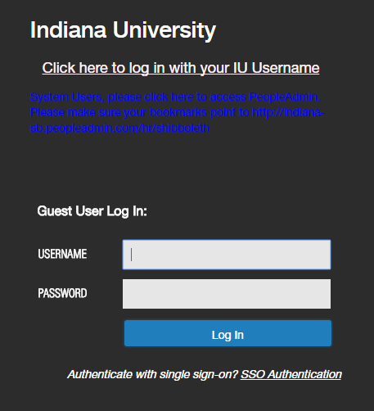

Once logged in, the home page will appear. The home page is a dashboard to help you keep track of actions and postings:

* Items in the Inbox require attention
* Items on the Watch List are things you have selected to keep an eye on during the approval process

Checklist for Academic Searches in PeopleAdmin

*Copies of all placed advertisements, letters, or any other efforts made to generate candidates must be maintained by the hiring unit for a minimum of five years from the time the position is filled—IUI Office of Civil Rights Compliance (OCRC) reserves the right to randomly audit positions to be sure the required documents are on file.

[Create a New Posting](https://faculty.medicine.iu.edu/join-us/recruitment-appointment/) for the vacant position in [PeopleAdmin,](https://indiana.peopleadmin.com/hr/) before ads are placed.

* Financial approval through [Fire Form](https://iusmfinancial-fireform.eas.iu.edu/online) is required to post a Tenure track or “Open” appointment type job
* **REGIONAL CAMPUSES**: Approval is required from Executive Associate Dean for Educational Affairs for a faculty search using the Education Affairs Administrative Action Request (AAR)

 [Place the ad](https://faculty.medicine.iu.edu/join-us/recruitment-appointment/) and begin recruiting after receiving approval from IUI Office of Civil Rights Compliance (OCRC) through PeopleAdmin. The position will automatically be posted on the IU Jobs website.

[Candidates apply](https://faculty.medicine.iu.edu/join-us/recruitment-appointment/) directly through PeopleAdmin.

[Review applicant](https://faculty.medicine.iu.edu/join-us/recruitment-appointment/) materials and send to the search committee chair for decision about next steps

Move all applicants to a required [Workflow State,](https://faculty.medicine.iu.edu/join-us/recruitment-appointment/) as the committee chair indicates

Move select applicants to “[Request Interview/OCRC Review](https://faculty.medicine.iu.edu/join-us/recruitment-appointment/)” workflow state **before** scheduling interviews

* *Remember, a second review of applicants may be requested by OCRC*

Continue to review applications and move to a required [workflow state](https://faculty.medicine.iu.edu/join-us/recruitment-appointment/) as appropriate

[Schedule candidate](https://faculty.medicine.iu.edu/join-us/recruitment-appointment/) for Interview after receiving approval from OCRC through PeopleAdmin.

 Move candidate to “[Applicant Declined Interview](https://faculty.medicine.iu.edu/join-us/recruitment-appointment/)” workflow state if interview declined

Move lead candidate to “[Interviewed, Ready to Submit Hiring Proposal](https://faculty.medicine.iu.edu/join-us/recruitment-appointment/)” workflow state

 [Create Offer Packet](https://faculty.medicine.iu.edu/join-us/recruitment-appointment/) as a **single PDF** in the following order for lead candidate

*OCRC requires an academic position announcement must be advertised in PeopleAdmin for 30 days before an offer can be made.*

* [Approval of Terms](https://faculty.medicine.iu.edu/join-us/recruitment-appointment/)
* [Offer letter template](https://faculty.medicine.iu.edu/join-us/recruitment-appointment/)
* CV
* Additional Required Documentation *for Tenure Track* on page 2 of the Approval of Terms document
* [Fire Form](https://iusmfinancial-fireform.eas.iu.edu/online) approval for MOU/Offer

*Financial approval through Fire Form is required to offer a job, even when Fire Form approval has been received to post the job.*

 [Start Hiring Proposal](https://faculty.medicine.iu.edu/join-us/recruitment-appointment/) in PeopleAdmin for the lead candidate

*OCRC requires an academic position announcement must be advertised in PeopleAdmin for 30 days before an offer can be made.*

 Send offer letter and [other required paperwork](https://faculty.medicine.iu.edu/join-us/recruitment-appointment/) to candidate after receiving approval in PeopleAdmin

*DO NOT SEND THE OFFER LETTER to the candidate until approval is received in PeopleAdmin*

Move Hiring Proposal to “[Offer Accepted](https://faculty.medicine.iu.edu/join-us/recruitment-appointment/)” once signed offer letter has been received

 Move all other interviewed candidates to “Interviewed, not selected”, “Withdrawn” or “[Offer Declined](https://faculty.medicine.iu.edu/join-us/recruitment-appointment/)”

*No applicants should show an “Application Received with email” status*

 Proceed to the [Academic eDoc Processing Checklist](https://faculty.medicine.iu.edu/join-us/recruitment-appointment/) for Hiring steps

# Create a Search Waiver Request

*Please note that submitting a search waiver request, even with proper documentation, does not guarantee approval. While FAPD may approve a waiver request, OCRC makes the final decision and handles each request case by case.*

*Financial approval through* [*Fire Form*](https://iusmfinancial-fireform.eas.iu.edu/online) *is required to request a waiver for a tenure track appointment type job.*

1. Click the Postings tab and select School of Medicine Waiver Request



1. Click in the upper right corner
2. Select Create from Position Type

## Create from Position Type

* 1. Title(s) – enter **WAIVER**: followed by the academic title and department (e.g., WAIVER: Assistant Research Professor of Anatomy, Cell Biology & Physiology)
  2. School/Unit – select IU School of Medicine (IN-MED-School) if needed
  3. Department – select the appropriate department or division. Regional campuses should select the appropriate regional campus as the department
  4. Workflow State– select “Application Received with Email”
  5. Reference Notification – do not make a selection
  6. Recommendation Workflow – do not make a selection
  7. Recommendation Document Type – do not make a selection
  8. Online Applications – leave Accept online applications check marked
  9. Click

1. Enter Posting Details
   1. FTE – Full-Time Equivalent (e.g. 1.0, 0.75)
   2. Title(s) – will auto-populate from the previous screen
   3. Salary Grade – enter the HRMS salary grade of the position (e.g. FTX, RSX, etc.)
   4. Recommending Offer To – enter the name of the recruit
   5. Salary – enter the amount of the IU base salary. Do not include the IUHP salary or any administrative supplements
   6. Position – select either new position or replacement for
   7. Position# - enter the HRMS position that will be used on the eDoc
   8. Expected Start Date – select the start date
   9. Expected End Date – do not select an end date
   10. Appointment Status – select from non-tenure track, tenure track for tenure probationary, or tenure for offers with tenure
       1. Financial approval through [Fire Form](https://iusmfinancial-fireform.eas.iu.edu/online) is required for a tenure track or tenure appointment type
   11. Waiver Circumstances – select the most appropriate waiver circumstance. For examples, definitions and use cases of waiver circumstances visit <https://faculty.medicine.iu.edu/join-us/recruitment-appointment/>
   12. Detailed Explanation – this is required with Other is selected in the Waiver Circumstances field
   13. IUSM Initiator Comments – enter comments as needed
2. Waiver Request Documents/Attachments
   1. Hover over in the right-hand column and choose Upload New to upload each of the following required documents
      1. Waiver: Required Detailed Justification – a letter signed by the hiring authority (e.g., chair, dean, director), addressed to the IUI Office of Civil Rights Compliance (OCRC), and includes an expected start date. The justification document must include the approved Job Posting/Waiver [Fire Form](https://iusmfinancial-fireform.eas.iu.edu/online/) for tenure track appointments.
      2. Waiver Candidate CV
      3. Waiver: Position Description – a document detailing the specific qualifications, skills, and experience needed for the position
      4. Offer Request – Prepare the IUSM Offer Packet
   2. Click
3. Icon  Description automatically generated Review the Posting details
4. If the posting needs to be revised, click to edit posting details
5. If no edits are needed, click and select the appropriate action from the drop-down menu
6. The waiver will be routed to the appropriate approver(s) for review. The initiator will receive an email notification once the waiver and offer have been final approved.
   1. If the initiator has not received notice of edits or posting approved within 2 business days, please email [acadadmn@iu.edu.](mailto:acadadmn@iu.edu)
7. Send the Offer letter and Offer Letter [Enclosures](https://faculty.medicine.iu.edu/join-us/recruitment-appointment/) to the candidate once the waiver is approved
8. Once the signed offer letter has been received from the candidate, proceed with the appropriate academic eDoc

# Creating a New Posting

1. Click the Postings tab and select School of Medicine



1. Click the +Create New Posting button in the upper right corner



1. Select either Create from Position Type or Create from Posting

## Create from Position Type

* 1. Title(s) – enter the academic title and department (e.g., Assistant/Associate/Full Professor of Pediatrics)
  2. Department – choose the appropriate department or division. Regional campuses should select the appropriate regional campus as the department
  3. Workflow State– select “Application Received with Email”
  4. References—PeopleAdmin can manage the reference letter collection process. Units are not required to use PA to collect reference letters, and this section may be left blank if you prefer to collect references outside of PeopleAdmin.
     1. ***If*** units choose to use PA to collect references, please go to page 9 of the [Indiana University](https://drive.google.com/file/d/15WzP1dDjYyz-F1Ok626UG58GrDEy4UF_/view) [PeopleAdmin User Guide.](https://drive.google.com/file/d/15WzP1dDjYyz-F1Ok626UG58GrDEy4UF_/view) General instructions are provided below.
        1. Reference Notification – select a workflow state that will trigger the referencing process.
           1. If the applicant has not already done so, they will be asked to supply information for references, and then requests for letters will be sent to those referees. The referees will then submit those letters via PeopleAdmin.
        2. Recommendation Workflow—Once the required number of references (you can set this number up later) has been submitted, the system will transition the applicant into a new workflow of your choice.
        3. Recommendation Document Type – use the default selection “Reference Letter”
  5. Click
  6. Enter Posting Details
     1. Title – enter the faculty title and unit (e.g., Assistant/Associate/Full Professor of Pediatrics).
        1. Enter **all applicable** ranks for the appointment type you select
        2. Put (DE) in front of the faculty title when this is a dually employed position, AND IUHP applicant tracking system (ATS) is the only ATS system used to capture all applicants.
           1. IUSM School Approver will select ‘Internally Posted’ at the approval stage.
           2. Internally Posted positions will not show up on the IU Jobs board or other IU-affiliated job boards (see Place the Ad)
           3. If a unit wants the posting to show up on the IU jobs board or other IU-affiliated job boards

Do not put DE in front of the faculty title

All applicants from the IUHP posting are required to also apply to the IUSM posting

Add a comment in the dialogue box that appears when ‘Take Action on Posting’ is selected, indicating that the unit wants the dually employed job posted externally and all applicants from the IUHP system will apply to the IUSM posting

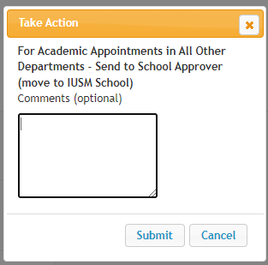

* + 1. Specific title –use for administrative and/or endowed chair titles, if applicable
    2. Appointment type – use the [Academic Appointment & Titles Guide](https://faculty.medicine.iu.edu/join-us/recruitment-appointment/) to identify and enter the correct appointment.
       1. Financial approval through [Fire Form](https://iusmfinancial-fireform.eas.iu.edu/online) is required to post a Tenure track or “Open” appointment type job
    3. Campus – select the appropriate IUSM campus
    4. Pooled Position – if you need to recruit more than one person to this posting, select yes
       1. Like all other postings, pooled position postings are limited to a 1 year posting length. If all positions have not been filled within 1 year, a new posting will need to be submitted, and the original posting will transition to a final workflow state.
    5. Number of Pooled Positions – a singular number (e.g., 2, 6, 26) indicating the total number of individuals you intend to hire on this posting. The HRMS position number is not required.
       1. The number of pooled positions should come from workforce planning discussions and decisions made by leaders in your unit (e.g., chair, director, service line administrator, vice chair, etc.)
    6. Position Announcement – list the details of the position (a posting [Compass](https://iu.instructure.com/courses/1763657/pages/pre-search-position-description-slash-announcement-drafting?module_item_id=17184140) is available for each appointment type [here](https://iu.instructure.com/courses/1763657/pages/pre-search-position-description-slash-announcement-drafting?module_item_id=17184140))
       1. Please use the IUSM [Inclusive Language Guidelines](https://iu.instructure.com/courses/1763657/pages/pre-search-position-description-slash-announcement-drafting?module_item_id=17184140) to ensure inclusiveness in the posting language.
       2. 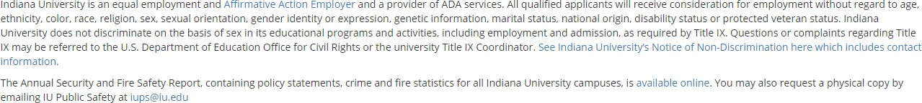Do Not include any EEO statement. The EEO statement pictured below is automatically added to each posting on the IU job board once the posting is approved.
       3. **DO INCLUDE** the IUSM [Diversity Statement](https://iu.instructure.com/courses/1763657/pages/pre-search-position-description-slash-announcement-drafting?module_item_id=17184140):

IUSM is committed to being a welcoming campus community and we seek candidates whose research, teaching, and community engagement efforts contribute to robust learning and working environments for all students, staff, and faculty. We invite individuals who will join us in our mission to improve health equity and well-being for all throughout the state of Indiana.

* + - 1. If information is included about the School of Medicine or Indianapolis, the only approved text that can be used is:

Indianapolis is the capital and most populous city in the State of Indiana. It is growing economically thanks to a strong corporate base anchored by the life sciences. Indiana is home to one of the nation's largest concentrations of health sciences companies. Indianapolis has a sophisticated blend of charm and culture with a wonderful balance of business and leisure. The growing residential base is supported by rich amenities and quality of life – the city possesses a variety of professional sports, arts venues, and outdoor recreation areas. Residents of this dynamic city and surrounding suburbs enjoy leading educational systems and top-ranked universities paired with a diverse population. Indianapolis International Airport is a top-ranked international airport that has been named “Best Airport in North America” by Airports Council International for many years. For additional information on life in

Indy: <https://faculty.medicine.iu.edu/relocation>

* + - 1. Information about the department, division, center, or lab is optional to include.
    1. Basic Qualifications – the degree indicated in this field should match the Highest Degree Earned column on the [Academic Appointment & Titles Guide](https://faculty.medicine.iu.edu/join-us/recruitment-appointment/) associated with the Appointment type entered above (6.c.)
    2. For Lecturers, a master’s degree is the only degree that can be entered in this field

ii. For Open, Tenure, Clinical, and Scientist, please use “terminal degree or doctorate degree required” instead of “MD or PhD required.”

1. Department contact for questions – list the name and contact information of the person the applicant should contact for questions.
2. Posting date – do not fill this in; the system will automatically populate this once approved
3. Do you plan to advertise this position – this is additional advertising outside of the IU Job board. Every posting in PeopleAdmin is automatically posted to Higher Ed Jobs and Insight into Diversity
4. If yes, where – list the additional job boards and outlets you plan to advertise this position in
5. [Search committees](https://iu.instructure.com/courses/1763657/pages/pre-search-committee-composition?module_item_id=17189217) should consist of a minimum of three individuals and a maximum of seven individuals. All committee members are responsible for contributing to the search process in a productive and meaningful way.
   1. You can leave this part blank if ‘Internally Posted’.
   2. Close/Remove From Web Date – insert a date if there is a specific date you will remove the posting.
   3. Click
   4. Add Supplemental Questions, if needed
      1. 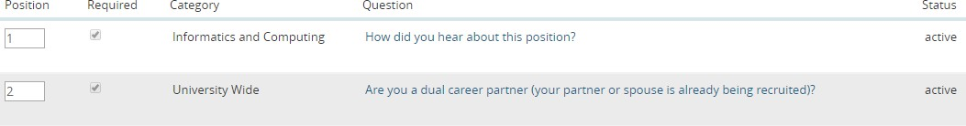All IUSM postings have two Supplemental Questions that cannot be removed or edited
      2. Click “Add a question” and search for a topic or click “Add a new one” to create a new question if there is not one in the existing list

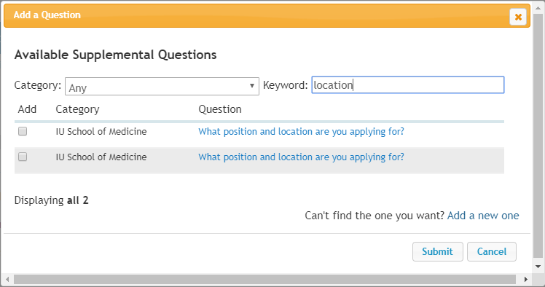

1. 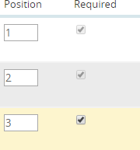Click the “Required” checkbox on the new question(s) added
2. New questions will be reviewed and approved by IUSM Faculty Affairs before appearing on postings
3. Click
   1. Applicant Documents
      1. Review the list of documents. If a document is optional, select the Optional radio button; if it is required, select the Required radio button.

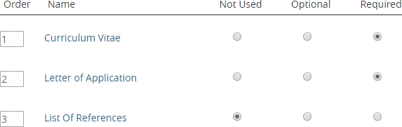

* + 1. Document types marked “Not Used” cannot be attached to the application
    2. Click
  1. Search Documents
     1. Upload the approved Job Posting/Waiver [Fire Form](https://iusmfinancial-fireform.eas.iu.edu/online) if the posting is for a tenure track or “Open” appointment type job
     2. Nothing is required for any other appointment types
     3. Click
  2. Enter Search Committee - *OCRC requires a minimum of three members of diverse race, gender and ethnicity*
     1. Click 
     2. Type the name of the user in the Search box
     3. Click 
        1. Check the Committee Chair check box if applicable
        2. If the member is not found in the search, click 
           1. Complete the Account Information
           2. Click
        3. For committee members that do not have an @iu.edu, @indiana.edu, @iupui.edu, or other Indiana University domains, information will be entered on the Guest User tab, in the Posting process
        4. Click
  3. Communication to the Search Committee
     1. Nothing is required to be entered in this section
     2. Click
  4. Enter Guest User information, if applicable - for committee members that do not have an @iu.edu, @indiana.edu, @iupui.edu, or other Indiana University domains
     1. Click 
     2. Enter the address of guest users by typing one email address per line in the box provided
     3. Click
     4. Guest users will receive an email from [iufacjob@indiana.edu](mailto:iufacjob@indiana.edu) with the guest username and password they will use to log into PeopleAdmin
     5. Click
  5. Reference Request Details
     1. Nothing is required to be uploaded in this section
     2. Click
  6. Summary
     1. Review the Posting details
        1. If the posting needs to be revised, click
        2. If no edits are needed, click and select the appropriate action from the drop-down menu
           1. For dually employed positions that are not (DE) internally posted, please add a comment to the dialogue box indicating that the unit wants the dually employed job posted externally and all applicants from the IUHP system will apply to the IUSM posting



The posting will be routed to the appropriate approver(s) for review. Once the position has been final approved, it will be posted and the initiator will receive an automated email notice. If the initiator has not received notice of edits needed or posting approved within 2 business days, please email [acadadmn@iu.edu.](mailto:acadadmn@iu.edu) **OCRC requires an academic position announcement to be advertised in PeopleAdmin for 30 days before an offer can be made**. This rule does not apply to ‘Internally-Posted’ positions.

If ‘Internally Posted’, the IUSM School Approver will make that change during the approval process. Once approved, you can copy the link to the posting and send to the applicant(s) via email.

Edit a Posted Position

Once a posting has been approved by OCRC, edits can only be made by emailing [acadadmn@iu.edu.](mailto:acadadmn@iu.edu)

# Place the Ad

The approved posting in PeopleAdmin will automatically be posted to the following job boards

* HigherEd Jobs
* Insight Into Diversity When placing ads in other venues
* The IU Equal Opportunity Employer statement must be included

Indiana University is an equal employment and affirmative action employer and a provider of ADA services. All qualified applicants will receive consideration for employment based on individual qualifications. Indiana University prohibits discrimination based on age, ethnicity, color, race, religion, sex, sexual orientation, gender identity or expression, genetic information, marital status, national origin, disability status, or protected veteran status. Indiana University does not discriminate on the basis of sex in its educational programs and activities, including employment and admission, as required by Title IX. Questions or complaints regarding Title IX may be referred to the U.S. Department of Education Office for Civil Rights or the university Title IX Coordinator. See Indiana University’s Notice of Non-Discrimination here which includes contact information.

The Annual Security Reports, containing policy statements and crime statistics for Indiana University campuses, are available through Public Safety and the IU Police Department websites at [protect.iu.edu/police-](http://protect.iu.edu/police-safety/annual-reports/index.html?_gl=1%2A3xznqo%2A_gcl_au%2ANDU2NjAxMjYuMTcxODIwOTM5OQ..%2A_ga%2AMTMzNjIyOTQxNC4xNzE4MjA3OTAx%2A_ga_61CH0D2DQW%2AMTcxODYzNzEwMy44LjEuMTcxODYzOTMzMy41Mi4wLjA) [safety/annual-reports/index.html.](http://protect.iu.edu/police-safety/annual-reports/index.html?_gl=1%2A3xznqo%2A_gcl_au%2ANDU2NjAxMjYuMTcxODIwOTM5OQ..%2A_ga%2AMTMzNjIyOTQxNC4xNzE4MjA3OTAx%2A_ga_61CH0D2DQW%2AMTcxODYzNzEwMy44LjEuMTcxODYzOTMzMy41Mi4wLjA) A paper copy will be provided upon request from Public Safety at [iups@iu.edu.](mailto:iups@iu.edu)

* All applicants must apply in PeopleAdmin
  + Include the URL found in the *Quick Link for Posting* box at the bottom of the Position Details in the Posting
* [Advertising Tips and Requirement](https://iu.instructure.com/courses/1763657/pages/search-advertising-tips-and-requirements?module_item_id=17184248)
  + It is important to cast a wide net and aim for a diverse applicant pool. Search committees can develop an advertising and outreach plan for every search to advertise as widely as possible and ensure that the job announcement is visible in several publications, professional organizations, and listservs.

# Candidates Apply

IUSM staff listed as the IUSM Initiator for a specific department or division in PA will receive email notices when applications for a job posting in that specific department or division have been received.

* Departmental staff are responsible for providing applicant materials to the search committee chair for review. See the instructions below to view an applicant’s materials
* As the committee chair identifies applicants for potential interview (e.g., meets minimum qualifications), move the applicant to the Review List workflow state.
* When the committee chair decides an applicant does not meet minimum qualifications or is not best qualified, move the applicant to the appropriate Rejection workflow state

## Reviewing Applicants

1. Click  and select School of Medicine
2. Chose the posting from the list or type the title of the posting in the search box and click 
3. Hover over  and select **View Applicants** from the drop-down.

### To view an applicant’s documents one at a time

1. Find the row with the applicant’s name
2. Click on the name of the document in the Documents column



### To view an applicant’s materials as a single file

1. From the ‘Applicants’ tab on the posting, click (applications details and all uploaded documents)
2. From the ‘Add Column’ dropdown menu, choose ‘Combined Document’ and wait for the page to refresh with the new column.
3. Find the row with the applicant’s name and click in the Combined Document column



1. After the page refreshes, click

### To view a collection of applicant documents

You can select and review more than one applicant document at a time.

1. From the ‘Applicants’ tab on the posting, check the boxes to the left of the applicant’s name
2. Hover over and select ‘Download Applications as PDF’
3. Select the types of documents you want to view, then click

### To view the applicant’s materials as separate documents

* 1. Hover over 

#### Select Create Document PDF per Applicant

* 1. After the page refreshes, click  in the Combined Document column

# Move Applicants to a Workflow State

*\*To remove the posting from the job board and to prevent additional applications, hover over and click*

*cid:image001.png@01D5DC36.83BE2900 . This should not be done before the 30-day posting period has been complete**d.*

## Review List

Move applicants to the Review List workflow state once the search committee chair has indicated that the applicant has met minimum qualifications and may be qualified for the next steps

### Single Applicant

1. Click the name of the applicant you wish to view/move from the **Applicants** tab on the posting
2. Hover over  and click
3. Click

### Multiple Applicants

1. Check the box next to the names of the applicants from the **Applicants** tab on the posting
2. Hover over  and click 
3. Click the drop-down menu next to



1. Click 
2. Click

## Rejection

Move applicants to the appropriate rejection reason workflow state once the search chair has reviewed the application materials and decided the applicant will not move forward.

### Single Applicant

1. Click the name of the applicant you wish to view/move from the **Applicants** tab on the posting
2. Hover over  and select one of the following reasons
3. Clic

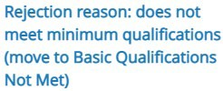

a.

b.

c. k

### Multiple Applicants

1. Check the box next to the names of the applicants from the **Applicants** tab on the posting
2. Hover over  and click 
3. Click the drop-down menu next to



1. Select one of the following for all applicants selected

a.

* + 1. ​



* + 1. ​

1. ​
2. Click

## Request Interview

### Single Applicant

1. Click the name of the applicant you wish to view/move from the **Applicants** tab on the posting
2. Hover over  and click 
3. Click

### Multiple Applicants

1. Check the box next to the names of the applicants from the **Applicants** tab on the posting
2. Hover over  and click 
3. Click the drop-down menu next to



1. Click
2. Click

## [Schedule Interview](https://iu.instructure.com/courses/1763657/pages/screen-best-practices-for-search-committee-interviews?module_item_id=17184252)

Use your departmental or unit procedures for scheduling and conducting interviews. More information about interviews is available in the [Recruiting Toolkit.](https://iu.instructure.com/courses/1763657/pages/screen-best-practices-for-search-committee-interviews?module_item_id=17184252)

## Declined Interview

### Single Applicant

1. Click the name of the applicant you wish to view/move from the **Applicants** tab on the posting
2. Hover over  and click
3. Click

### Multiple Applicants

1. Check the box next to the names of the applicants from the **Applicants** tab on the posting
2. Hover over  and click 
3. Click the drop-down menu next to



1. Click
2. Click 

## Interviewed

### Lead Candidate

1. Click the name of the applicant you wish to view/move from the **Applicants** tab on the posting
2. Hover over  and click
3. Click

### Not Selected

1. Check the box next to the names of the applicants from the **Applicants** tab on the posting
2. Hover over  and click  .
3. Click the drop-down menu next to



1. Click A picture containing text  Description automatically generated  or 
2. Click

Offer Packet *-* ***OCRC requires*** *an academic position announcement must be advertised in PeopleAdmin for* ***30 days*** before an offer can be made***.***

## Approval of Terms/Required Documentation

* + Complete the [Approval of Terms](https://faculty.medicine.iu.edu/join-us/recruitment-appointment/) form

## Offer Letter Template

* + Fill in all details on the [Offer letter template](https://faculty.medicine.iu.edu/join-us/recruitment-appointment/)

## CV

* + Retrieve the CV from the applicant’s documents

## Other Required Documents

* + Refer to the Required Documentation section of the Approval of Terms form and the Additional Required Documentation for Tenure Track on page 2

## Fire Form approval

* + After [Fire Form](https://iusmfinancial-fireform.eas.iu.edu/online/) approval has been received for an Offer/MOU, the initiator of the Fire Form will print the form from the My Entries section of the Fire Form application using a print browser function. This is the only print option that will include the Routing Log, which shows the form was approved and all form details.

## Assemble Offer Packet Document

1. Combine all documents into a single PDF
2. Place the documents in the same order they are listed on the Approval of Terms form, Required Documentation section, and Additional Required Documentation for Tenure Track on page 2
3. Save the PDF document

Hiring Proposal - ***OCRC requires*** *an academic position announcement to be advertised in PeopleAdmin for* ***30 days*** before an offer can be made***.***

## Create Hiring Proposal

1. Click  and select School of Medicine
2. Choose the posting from the list or type the title of the posting in the search box and click 
3. Click on the tab
4. Click on the name of the applicant

cid:image001.png@01D5D81F.DB307730 

1. Click on
2. Choose
3. Ensure the name and appointment information on the screen is correct and enter the start date

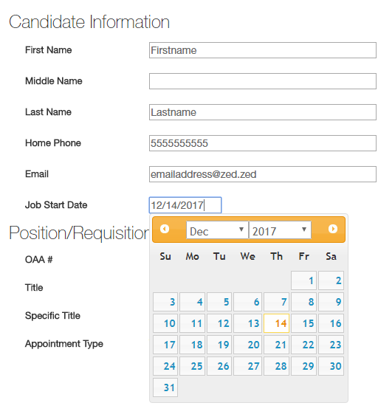

Choose

1. ​
2. Choose in the Offer Packet Document row
3. Click to select the Offer Packet you saved
   1. If you receive an error message that the file is too large, please see the Troubleshooting section for help
4. Click
5. Click
6. Select the appropriate option for your department from

## Edit a Returned Hiring Proposal

If an Approver determines that the Offer Packet attached to a Hiring Proposal requires edits, the proposal will be returned to the Initiator in PeopleAdmin. The approver will outline the required edits in a dialogue box that will be included in the automated email generated from PeopleAdmin notifying the initiator of the status. The text from the dialogue box will also be visible in the History tab of the Hiring Proposal.

1. Make necessary changes to the offer packet documents
2. Save the revised offer packet
3. Click  and select School of Medicine
4. Find the name of the applicant in the list
5. Hover over in the right-hand column
6. Click Edit 
7. Update if necessary
8. Click
9. Hover over
10. Click Unassign 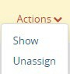
11. Hover over
12. Chose Upload New
13. Click
14. Select your document
    1. If the file is too large, please see the Troubleshooting section for assistance
15. Click
16. Click
17. Select the appropriate option for your department from

# Finalize Hiring Proposal

## Offer Accepted

1. Send the approved Offer letter and Offer Letter [Enclosures](https://faculty.medicine.iu.edu/join-us/recruitment-appointment/) to the candidate once the Hiring Proposal is approved
2. Once the candidate signs the offer letter, proceed with the appropriate academic eDoc
3. Once the signed offer letter has been received from the candidate, move the Hiring Proposal to a Workflow State
4. Click  and select School of Medicine
5. Find the name of the applicant in the list
6. Hover over in the right-hand column
7. Click View 
8. Hover over
9. Select the appropriate Workflow Action
10. The Workflow Action cannot be changed once saved, so wait to make this selection until absolutely certain.
11. Click in the dialog box

## Offer Declined

1. Click  and select School of Medicine
2. Chose the posting from the list or type the title of the posting in the search box and click
3. Click on the tab
4. Click on the name of the applicant
5. Hover over  and click
6. Click

# Final Transitions

## Final Transition on Applicant

1. Click  and select School of Medicine
2. Chose the posting from the list or type the title of the posting in the search box and click
3. Click on the tab
4. Click on the name of the applicant
5. Hover over  and click

cid:image001.png@01D5DC32.D2600000 

1. Click

## Final Transition on Posting

1. If after your search process, there was no candidate(s) hired, choose the posting from the list or type the title of the posting in the search box and click 
2. Hover over  and click 
3. Complete the following steps once the Hire/Transfer eDoc has been submitted
4. Click  and select **School of Medicine**
5. Chose the posting from the list or type the title of the posting in the search box and click 
6. Hover over  and click



# Troubleshooting

## Viewing Draft Applications for a Position

*It may be helpful to know if anyone has started the application process for a position and has not submitted it.*

1. Go to the posting and click ‘Applicants’.

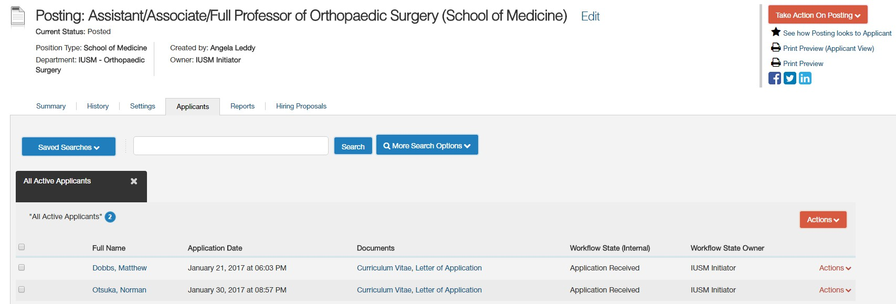

1. Click ‘More Search Options’ and check the box next to ‘Draft?’. Then hit the ‘Search’ button.

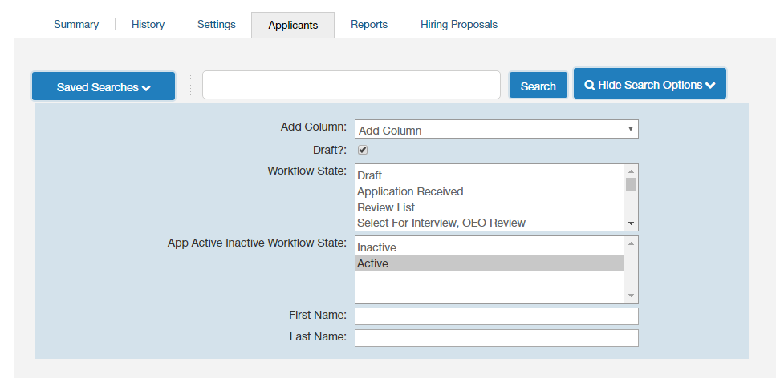

1. You will now see a list of any applications that have been started for the position.

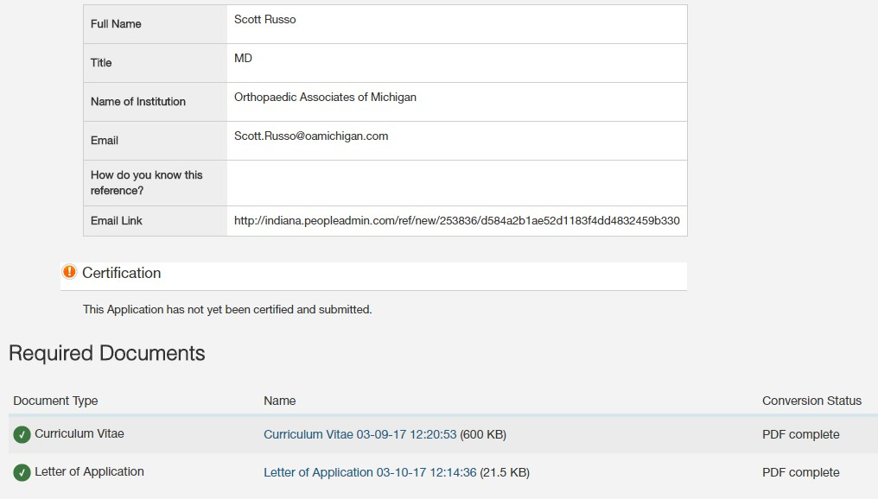

1. Select the applicant you would like to review. You will see their entries into the application along with the missing or incomplete items, which will be designated by

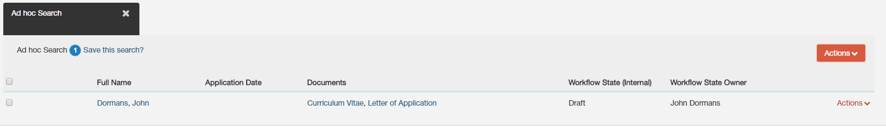

## File Too Large for Proposal

If the Offer Packet file is too large to be uploaded in the Hiring Proposal, open the PDF document

* 1. Click File
  2. Hover over Save as Other
  3. 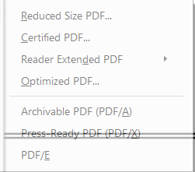Select Reduced size PDF
  4. Click ‘Ok’ in the pop-up box

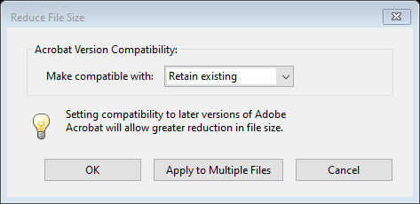

* 1. Save the file to a local drive
  2. Return to the Hiring Proposal to try the upload again